Alliance Learning
Self-Assessment Report

January 2018
Key Contact: Julie Robinson, Chief Executive Officer
Address: Alliance Learning
Horwich
Bolton
BL6 5UE

Telephone: 01204 677800

Fax Number: 01204 669217

Table of Contents

Description | Page Number
Summary of Grades | 3
Organisational Overview | 4
Effectiveness of Leadership and Management | 8
Quality of Teaching, Learning and Assessment | 12
Personal Development, Behaviour and Welfare | 17
Outcomes for Learners | 23
Apprenticeship Departmental Overviews | 28

Summary of Grades

Overall Effectiveness | Grade:2
Effectiveness of Leadership and Management | Grade:2
Quality of Teaching, Learning and Assessment | Grade:2
Personal Development, Behaviour and Welfare | Grade:2
Outcomes for Learners | Grade:2
Business Administration and Law | Grade:2
Engineering | Grade:2
Childcare | Grade:2
Health and Social Care | Grade:3
Subcontractors
Nowskills (Until July 2017) | Grade:2
Dentrain Professionals Ltd (Last new starts December 2017) | Grade:2
Transport Training Academy TTA (Last new starts April 2017) | Grade:2
Apprenticeships | Grade:2
Traineeships (Not delivered after February 2017) | n/a

Self-Assessment Report - Organisational Overview

Name of Organisation:  Alliance Learning | Report Date:  January 2018
Introduction To The Organisation
Alliance Learning is a private company limited by guarantee and a registered charity. It was formed in April 2001 from the merger of Bolton Training Group and CLEEA Training. Prior to this, the company has traded as Bolton Training Group. The Company is celebrating 52 years of training in 2018. Alliance Learning has an engineering multi-disciplinary training centre, incorporating the head office in Horwich.

Alliance Learning holds a contract with the Education & Skills Funding Agency for Apprenticeships provision. Programmes delivered include Intermediate and Advanced Apprenticeships in Business Administration, Customer Service, Childcare and Health and Social Care and Engineering. Alliance Learning also offer Higher Apprenticeships in Engineering and Business and Professional Administration and Management.

Alliance Learning sub-contracts to local colleges for a small number of learners to complete BTEC qualifications as part of their framework in Engineering. Alliance Learning had sub-contracting partnerships with Dentrain Professionals Ltd to deliver Dental Nursing Apprenticeships, Transport Training Academy to deliver qualifications in Driving Goods Vehicles and Nowskills to deliver IT Apprenticeships. From January 2018, Alliance Learning no longer sub-contracts for any new starts.

Socio Economic Information

The Bolton Borough comprises of approximately 276,800 people, taken from the Census 2011. Eleven per cent come from ethnic minority groups. This is a 6% increase from the census of 2001, which was just below the Greater Manchester and England/Wales increase of 8%, with 50.7% of the population being female.

Unemployment for the Bolton Borough is 4.9%, of which 61.2 % are males and 38.8% are females. National unemployment rate curently stands at 4.3% for ages 16 and over (Sep-Nov 2017).

The number of young people achieving a standard 9-4 pass at English and maths GCSE was 61.5% in 2017, compared to the national average of 59.1%. The proportion of people with a National Vocational Qualification at level 3 or above is 46.4%, which is below the national rate.

Organisational Structure
Alliance Learning is led by 8 voluntary Board Members, each of whom play a lead role in companies/organisations in the sectors within which we deliver in the North West region. The day to day responsibility of the company is that of the Chief Executive Officer (CEO). The Curriculum Manager and Engineering Manager lead the Work Based Learning Division. There is also a Projects, Contracts and Quality Manager, who is responsible for the SFA funding and quality improvement for the organisation. All these roles are managed under the direction of the Operations Executive. A Commercial Manager leads a team for non-funded training and there is also a Marketing Manager who are managed under the direction of the CEO.

The Self-Assessment Process
This report has been completed in conjunction with stakeholders, employers, learners and staff. The information and judgements were gathered from meetings with all delivery staff; questionnaires and observations of teaching, learning and assessment. This was then collated and produced by the Operations Management team.

Numbers of Learners Currently On Programme (December 17)
Subject Sector | Programme | Number
Business Administration/Customer Service/Business Management | Intermediate Apprenticeships  Advanced Apprenticeships  Higher Apprenticeships | 106  24  11
Standards | Customer Service Practitioner  Business Administrator  Team Leader/Supervisor  Operations/Departmental Manager | 1  2  1  2
Childcare/Direct Learning Support | Intermediate Apprenticeships  Advanced Apprenticeships | 25  22
Engineering | Intermediate Apprenticeships  Advanced Apprenticeships  Higher Apprenticeships | 41  194  6
Standards | Diploma in Advanced Manufacturing and Engineering - Machinist (Development Competence) | 5
Health and Social Care | Intermediate Apprenticeships  Advanced Apprenticeships | 34  23
Dental Nursing (Sub-contracted) | Advanced Apprenticeship | 14
Standards (Sub-contracted) | Dental Nurse | 12

This self assessment report reflects the following company strategies:

- Business Plan
- Teaching, Learning and Assessment Strategy
- Maths, English and ICT Strategy
- IAG Strategy

Please follow the link below to our previous Inspection Report (July 2013):

http://reports.ofsted.gov.uk/inspection-reports/find-inspection-report/provider/ELS/50387

Short Inspection Letter (May 2017)

Ofsted recommendations for improvement and distance travelled (May 2017):

- ‘Managers implement effective actions to improve the quality of teaching, training, learning and assessment that apprentices on health and social care programmes receive, so that they make good progress and achieve.’

Distance travelled:

- 23% increase in overall achievement rate.
- Senior staff appointed to drive success in underperforming areas.
- Continuation of effective weekly performance management of staff through progress reporting to flag up learners 10% behind target by Senior Managers.
- The implementation of Learner Status flags up slow progress learners.
- Increased OLA and mentoring os team.

- ‘Staff evaluating the quality of teaching and learning focus on the impact of teaching and training practices on apprentices’ vocational skills development.’

Distance travelled:

- Re-aligned OLA (Observation of Learning and Assessment) team to ensure robust judgements were made.
- All delivery staff have an allocated mentor and subject specialist to enable ‘risk taking’ to aspire and achieve Outstanding.
- Regular and meaningful staff CPD to aspire to Grade 1 to improve feedback to learners.
- All grades are now either Outstanding or Good: Grade 1 = 13% and Grade 2 = 87%).
- Best Practice continues to be shared with all delivery staff on a monthly basis.

- ‘All LDOs check thoroughly apprentices’ depth of understanding and knowledge and the quality of their written work to ensure that apprentices achieve their potential.’

Distance travelled:

- Addressed through standardisation and departmental meetings to share best practice.
- The IQA (Internal Quality Assurance) process, demonstrates improvements in learners work.
- All delivery staff have an allocated mentor and subject specialist for OLA, to check learners depth of understanding and enable ‘risk taking’ to aspire and achieve Outstanding.
- Improved work scrutiny on progress, vocationally relevant feedback and checks for learners depths of understanding.
- Started to see more use of ‘Journal Enties’ on the e-portfolio, with reflective evaluation to highlight what is being learned and linking this to off the job training.

- Managers develop effective arrangements to ensure that all apprentices receive their on- and off-the-job training entitlements.

Distance travelled:

- An ‘off the job’ training plan is completed in collaboration with the learner and employer at the beginning of the apprenticeship prgramme to ensure that entitlement is planned to meet all areas of development.
- Commitment and the ‘off the job’ training plan is monitored and reviewed at LDO visits to ensure relevance and compliance.
- Weekly e-portfolio reporting has now been introduced and this informs Seniors and Managers of those apprentices failing to meet the training entitlements. Swift remedial action is taken to rectify this.
- Dedicated team also audit off the job training on a monthly basis to ensure this is meaningful and relevant to learners starting points.
- Started to see more use of ‘Journal Enties’ on the e-portfolio, with reflective evaluation to highlight what is being learned and linking this to off the job training.

Effectiveness of Leadership and Management
Demonstrate an ambitious vision, have high expectationsfor what all learners can achieve and ensure high standards of provision and care for learners.

Leaders, managers and members of the Board have a clear focus on learners and apprentices and their intended outcomes. Leaders and managers are involved in all aspects of strategic planning for the organisation, where challenging key performance indicators are set. This has ensured that overall achievement rates have increased in 2016/17 and timely achievement has remained high and well above national averages. The Operations Executive provides honest, detailed and accurate information regularly to the company’s board that has a governance responsibility. This information includes the results of teaching and learning evaluations and apprentices’ achievements in each vocational area. This ensures that the board members are well informed about all aspects of the provision. They use this information well to support and challenge senior managers to make further improvements. Members of the Board challenge leaders and managers in being responsive to local economic needs to improve progression opportunities. From September 2017 delivery of Apprenticeship standards has commenced with a small portion of learners. Alliance Learning continues to work collaboratively with the University of Bolton, through delivery of Foundation Degrees in Early Years and in developing delivery of Apprenticeship Standards. This will increase progression onto degree apprenticeships and Higher Education, which demonstrates our high expectations and progression opportunities for learners.

Improve staff practice, teaching, learning and assessment through rigorous performance management and appropriate professional development.

Senior managers have high expectations for the success of apprentices and have set demanding targets for their achievements. Strong and effective performance management resulted in the large majority of apprentices completing within their planned time. In 2016/17, the proportion of apprentices who completed successfully on time on early years, engineering, administration and business management programmes was high. Around 10% of apprentices are on health and social care programmes. In 2016/2017, achievement rates of health and social care apprentices improved by 21%. Managers’ recent actions, such as more-robust performance management of LDOs and more frequent visits to monitor the progress of, and provide extra support to, this group of apprentices, improved overall progress, however, was not quick enough to see an improvement to timely achievement.
There is good development of delivery staff to improve, following lesson observations, work scrutiny and the IQA process. Meaningful CPD is facilitated for all staff through identified themes and individual needs. This is reflected within the good improvements to teaching and learning session grades in which none required improvement. The OTLA team now has a clear focus on the learners’ journey over time. Thorough work scrutiny is undertaken as part of OTLA to measure the quality of the learners’ journey from the start of their programme.

Evaluate the quality of the provision and outcomes through robust self assessment, taking account of users’ views, and use the findings to develop capacity for sustainable improvement.

Our Ofsted inspection identified that Alliance Learning evaluated the quality of provision accurately in the self-assessment report and have a detailed improvement action plan. Apprentices on early years and playwork, engineering, administration and business management programmes receive good-quality teaching, training, learning and assessments. Senior managers have been decisive in removing provision from a poor-performing subcontractor. They have stopped offering traineeships because trainees for two consecutive years did not achieve well. Leaders and managers have recognised that the provision that the apprentices in health and social care receive is not good enough. Despite the recent changes, until very recently the pace of improvements in health and social care apprenticeship programmes had been too slow. Improvements to overall achievement rates, demonstrates some impact, however, Alliance Learning no longer offers Health and Social Care Apprenticeships and has removed this provision from NAS.
An effective collaborative approach is used to gain feedback from staff, learners and employers. Sector Self Assessment Groups establish strengths and areas for improvement from staff and Learner Forums further enhance the quality of provision for learners who attend the centre to inform the Quality Improvement Plan (QIP). These plans are monitored regularly to ensure improvements with tight deadlines for each area of the curriculum. Alliance Learning also takes into account feedback gained from external sources and was one of the first providers in the country to gain accrediation of BS 76005 Code of Practice for Valuing People through Diversity and Inclusion, in which we were recognised for listening to the views of all people.

Provide learning programmes or curriculum that have a suitable breadth, depth and relevance so that they can meet any relevant statutory requirements, as well as the needs and interests of learners and employers, nationally and in the local community.

All learning programmes meet relevant statutory requirements and where appropriate, learners are encouraged to develop their maths, English, ICT and work skills beyond the requirements of their programme. Some learners complete units at a higher level or additional units outside of their framework in Business and Engineering, to enable stretch and challenge. The introduction of delivery of the Early Years Foundation Degree and collaboration with the University of Bolton helps signpost learners onto higher education and further develops learners skills relevant to the workplace and meet their future career aspirations. Leaders and managers are proactive in attendance and participation of local and national groups in order to strategically identify delivery of programmes that meet local and national economic needs. These inform the company Business and Operational plans. Attendance with local groups includes; Group Training Association England (GTAE), AELP, Team Bolton, Greater Manchester Learning Provider Network (GMPLN). This can be evidenced through the introduction of a small number of Apprenticeship Standards in Business Administrator, Mechanical Engineering, Level 3 Team Leading and the Level 5 Operations Manager. Alliance Learning continues to be involved in the writing and approval of Apprenticeship Standards with our own SME Employers through GTA England and Pearson to ensure local and national economic needs are met.
Successfully plan and manage learning programmes, the curriculum and careers advice so that all learners get a good start and are well prepared for the next stage in their education, training or employment.

Curriculum areas are planned and managed well with experienced and dedicated staff. Managers’ actions, such as more-robust performance management of LDOs in Health and Social Care and more frequent visits to monitor the progress of, and provide extra support to, this group of apprentices, are starting to improve their progress but the impact is starting to improve the in year timely achievement of this area for 2017/18. In order to increase learner retention and achievement rates, dedicated Employer Engagement Officers sit under their curriculum areas and liaise with the staff for the recruitment of learners. The Employer Engagement team completed Level 3 Advice and Guidance, to further enhance the offer of robust IAG. Accreditation of the Matrix Standard in May 2015 (continuous improvement check May 2016 & 2017 validated) identified that learners are well prepared for the next stage in their education. ‘The new enhanced review is very much in line with national policy requirements and in response to identified need; the development is a formalisation and standardisation of the on-programme review process which did not always fully document discussions and interventions. The process focuses much more on careers and personal issues than hitherto, contributing to better whole person development.’
Actively promote equality and diversity, tackle bullying and discrimination and narrow any gaps in achievement between different groups of learners.

Promotion of Equality, Diversity and Inclusion is good. Staff receive annual training on Equality, Diversity, Inclusion and Safeguarding/Prevent to allow them confidence in relating to a variety of differing groups. Delivery staff conduct robust progress reviews and discuss relevant and meaningful topics to extend the learners’ knowledge and understanding. Evaluation of teaching, learning and assessment confirm good promotion of equality, diversity and inclusion. Safeguarding/Prevent topics and an embedded additional learning aim on the eportfolio system, Learning Launchpad, endorses Alliance Learning’s policies to tackle bullying and discrimination. Regular learner announcements on eportfolio also highlight Prevent, British Values and protected characteristics. Learners from ethnic backgrounds achieve well, although there are very low numbers. Alliance Learning engaged with 160 local schools and other referral partnerships in 2016/2017, attending over 800 careers events in an effort to increase engagement for ethnic backgrounds to reflect local demographics. Overall achievement rates have risen and is now broadly comparable for all ages. 25+ learners timely achievement has improved on the previous year, requires improvement. Males and females generally achieve at the same level across all sectors.

Actively promote British values.

Most apprentices benefit from good discussions about treating individuals fairly and respecting differences, such as differences in beliefs and gender. Managers have ensured that most LDOs are confident about promoting values such as democracy, the rule of law and individual liberty. As a result, most LDOs promote British values confidently and effectively by making them relevant to apprentices’ experiences, for example by discussing current affairs and ‘Hot Topics’. A monthly newsletter is distributed to staff from The local Prevent Co-ordinator to further enhance these ‘Hot Topics’. OLA and work scrutiny show British Values being incorporated, naturally into learnng sessions and in feedback to learners. Visual promotion of British Values throughout the learning environment further highlights expectations of staff and learners in all aspects of life. All employers’ receive information on their responsibilities in reference to British Values and The Prevent Duty, however, further understanding of their roles and responsibilities, needs to be continually developed.
Make sure that safeguarding arrangements to protect young people and learners meet all statutory and other government requirements, promote their welfare and prevent radicalisation and extremism.

Leaders and managers have prioritised apprentices’ protection well. Managers have developed comprehensive policies and procedures on keeping apprentices safe. Staff have ensured that apprentices are well informed about the risks associated with extreme views and taking radical actions. All staff, including the board members, have received appropriate training and are aware of the signs that may indicate that an apprentice is at risk. This has included updates from The North West Counter Terrorism Unit on extremist groups and local activity. Delivery staff have meaningful conversations with learners about extremism, radicalisation and British Values, via relevant topics and information received from the Local Prevent Co-ordinator. A Prevent duty risk assessment has been developed with associated action plans and implemented effectively.The staff with teaching and training responsibilities have undergone Disclosure and Barring Service (DBS) checks. They promote good practices in health and safety, for example by ensuring that apprentices in welding workshops wear appropriate personal protective equipment. Apprentices feel protected and safe at the training centre and in work. Apprentices are clear about the safe use of the internet and social media. The manager with responsibility for safeguarding monitors closely apprentices’ access to websites that may put them at risk. When issues arise, apprentices feel confident to report their concerns because they are certain that the staff take their concerns seriously and support them well.

Quality of teaching, learning and assessment
2016-2017 Data

August 2016 - July 2017
KEY: Outstanding = 1 Good = 2 Requires improvement = 3 Inadequate = 4
Observations
Route |  | Grade 1 | Grade 2 | Grade 3 | Grade 4 | Total
Engineering |  | 1 | 9 |  |  | 10
Health/Early Years |  | 0 | 4 |  |  | 4
Administration |  | 1 | 5 |  |  | 6
Functional Skills |  | 1 | 1 |  |  | 2
IAG |  | 0 | 2 |  |  | 2
Total |  | 3 | 21 |  |  | 24
Percentage 2016- 2017 |  | 13 | 87 |  |  | 100%
Percentage 2015 - 2016 |  | 28 | 72 |  |  | 100%

Subcontractors
Provider | N/G | Grade 1 | Grade 2 | Grade 3 | Grade 4 | Total
Bolton College |  | 1 | 1 |  |  | 2
Dentrain |  |  | 1 |  |  | 1
NowSkills |  |  | 1 |  |  | 1
TTA |  |  | 2 |  |  | 2
Wigan and Leigh College |  |  | 2 |  |  | 2
Total |  | 1 | 7 |  |  | 8
Percentage 2016 - 2017 |  | 13 | 77 |  |  | 100
Percentage 2015 - 2016 |  | 14 | 86 |  |  | 100

RAG Rating | Green | Amber | Red
Reviews | 71% | 16% | 13%
Feedback | 78% | 16% | 6%
Overall | 76% | 16% | 8%

Teaching, Learning and Assessment is very good. There has been a strong improvement of good grades over the last 3 years. Staff received relevant, consistent and meaningful CPD to augment delivery. In 2016/2017, Alliance Learning increased its high expectations of learning sessions and all observations were graded good or oustanding. The OLA process was re-structured in 2016/2017 to assign a mentor to delivery staff to be used to support development and the inclusion of subject specialists during observations improved the work scrutiny process and ensured the content of learning was relevant and learners were making good progress. Rigorous paired observations worked particularly well to solidify judgements and give meaningful, relevant feedback to staff. Work Scrutiny was further developed to focus more rigorously on quality of learner work and feedback from delivery staff. The consistency and regularity of highly effective assessment practices is confirmed by all Awarding Organisations, across all department to reflect good and oustanding grades.

Quality of Teaching, Learning and Assessment Continued…

Teachers, practitioners and other staff have consistently high expectations of what each learner can achieve including the most able and the most disadvantaged.

Learners are set high expectations during their apprenitceship. Good reviews, learning sessions and thorough OneFile eportfolio assessment plans, successfully promote this. Learners benefit from SMART targets and regular and flexible contact from their individual LDO (Learning and Development Officer) to ensure they achieve well. All learners receive an individualised learning plan which identifies specific needs, allowing for flexible timescales so that, regardless of any barriers, they become successful and achieve. However, ICT resources for disadvantaged learners requires additional investment, along with staff development to support learners with specific needs. The introduction of the “Ten-Point Star” supports learners who are disadvantaged and helps to inform tailored learning plans and commitment statements to ensure they have the best chance of achieving. Good Practice is regularly collated, moderated and shared with delivery staff on a monthly basis to further improve learners’ experiences.

Teachers, practitioners and other staff have a secure understanding of the age group that they are working with and have relevant subject knowledge that is detailed and communicated to learners.

Alliance Learning staff are highly experienced in working with a variety of age ranges. Investment in new technologies, and the use of ILT within all learning sessions, successfully engages learners, with 90.5% of learners confirming this. Staff are adaptable within the workplace, utilising technology and paper-based resources to meet a variety of learning styles and ages. Learners feel that their lessons are well-taught, with 88% confirming this. 100% of observations of learning were graded good or better for 2016/2017 to further augment the above.Health LDO’s are flexible in supporting 25+ learners around work (shifts) and family commitments. Length of stay has been extended for this age range and all Advanced Apprentices are now interviewed by a sector specialist prior to enrolment to improve retention and timely achievement.

Assessment information is gathered from looking at what learners already know, understand and can do, and is informed by their parents/previous providers as appropriate.

All Learners complete a rigorous Initial Assessment and Diagnostic to ascertain Maths, English and ICT starting points. We recently introduced BKSB to do this to ensure a more robust outcome for the learners. This has been extended to include Speaking and Listening, Writing and enhanced Mathematics diagnostics. This ensures learners are stretched and challenged at the right levels, regardless of the programme requirements. Learners have started to self-assess their Maths, English and ICT skills which effectively facilitates good learner engagement from the start. Staff gather a suitable range of assessment information on learners’ prior attainment and work experience to ensure they are entered onto an appropriate training programme, building on their existing knowledge and skills. Regular open evenings are provided to facilitate parental involvement in learners’ starting points and career opportunities.

Assessment information is used to plan appropriate teaching and learning strategies, including to identify learners who are falling behind in their learning, or who need additional support, enabling learners to make good progress and achieve well.

Initial assessment of learners is good. BKSB has been introduced to provide a more rigorous initial assessment and diagnostic in maths, English and ICT regardless of their framework requirements. Beneficial learning styles questionnaires, also from this assessment, are gleaned to plan appropriate learning sessions that meet individual needs. Starting points in personal development, behaviour and welfare are assessed through our bespoke “Ten-Point star”, which helps to identify extra support a learner may require.
Good use of OneFile reporting allows for early identification of learners who may be making slow progress. These reports are utilised very well in the majority of occupational areas. They provide the scaffolding for which detailed one to ones are completed to target learners falling behind in their learning, using a variety of differing assessment methodologies. Further engagement from Health learners is necessary to reflect accurate progress on the OneFile system.
Dedicated Functional Skills tutors provide well planned and resourced individual and group sessions tailored to their specified needs, and this is now supported through BSKB, which complements delivery. Timely completion of functional skills requires improvement to increase the number of learners not achieving on time in Health. Increases to standard length of stay and entry requirements have been implemented to help address this area.

Learners understand how to improve as a result of useful feedback from staff and, where relevant, parents, carers and employers understand how learners should improve and how they can contribute to this.

Learners benefit from regular and meaningful feedback from staff . Over the last 12 months, feedback has improved significantly. Learners are informed what they have achieved, where they need to be and how to get there. Most recently, staff make beneficial reference to learners’ softer skills in relation to Personal, Learning and Thinking Skills as well as positive reference to Functional maths, English and ICT. However, feedback to parents, carers and employers requires improvement. Further utilisation of the eportfolio system to engage better with parents, carers and employers is currently being promoted.

Engagement with parents, carers and employers helps Alliance Learning to understand how learners are doing in relation to the standards expected and what they need to do to improve.

In most areas, employer engagement is good, although employer engagement in Health requires further improvement, to provide a clear focus on the learners falling behind in their learnng. All employers receive regular updates on learner progress through reviews which covers all aspects of the learner’s framework and progress made since the last review. Engagement with parents and carers is improving. Alliance Learning acknowledges this and Parents/Carer evenings now take place. Where parents cannot attend, updated progress reports are sent out every 6 months to keep them fully informed.

Equality of opportunity and recognition of diversity are promoted through teaching and learning.

Learner differentiation is promoted particularly well through all teaching, learning and assessment activities. This has been reflected in the number of outstanding and good grades achieved throughout the 2016/17 contract year. All sessions contain differentiated activities which meet individual learning styles well. There are particularly strong instances of linking cultural examples within occupational sectors within Engineering. Learners are now challenged to discuss topical issues and this is helping to support tolerance and vigilance. Delivery staff are more confident of challenging issues and teaching to tolerance. Observations of teaching and learning capture naturally occurring promotion of British Values and learners are starting to see the link to these as part of their apprenticeship and every day life.

Personal Development, Behaviour and Welfare
Pride in achievement and commitment to learning is supported by a positive culture across the whole provider.

Promotion of pride in achievement is good. Alliance Learning celebrates learners’ achievements through its Annual Awards Evening, nominations for national awards, inspirational case studies, social media achievement and through motivational and encouraging feedback during the programme. The eportfolio system allows 24 hours per day access, which has enabled some learners to accelerate their apprenticeship programme and complete early. Staff promote Alliance Learning’s Mission Statement, “Success Through Learning” particularly well. This is evidenced in the increased achievement rates for 2016-2017 and evidenced within the eportfolio.

Self-confidence, self-awareness and understanding of how to be a successful learner.

Learners and apprentices are highly motivated, behave well and show respect for each other and staff. Through observations of teaching, learning and assessment, evidence is seen of improvement in confidence levels and their self-esteem. Learners have a clear understanding of where they are in their learning and how to succeed through motivational feedback and learning sessions. Changes to the review process make reference to learners’ softer skills and engage learners confidence in self assessing themselves, alongside their employer and LDO to tri-angulate the process. Delivery staff set high expectations of learners for on and off the job training and employers are now engaged in these softer skills as part of the review process. Thorough safeguarding training of staff has allowed them to engage more effectively with learners. This has resulted in an increase in potential safeguarding concern referrals as learners confidently discuss their feelings.

Choices about the next stage of their education, employment, self-employment or training, where relevant, from impartial careers advice and guidance.

Results from Learner Satisfaction Surveys (May 2017) show that learners receive a good experience from Alliance Learning.

(Please see Learner Satisfaction data on the following sheet)

Learner Satisfaction Survey Results – May 2017

Learner satisfaction scores have either remained the same or increased on May 2017 results in all of the areas above.

Overall, information, advice and guidance is good for the organisation and this was acknowledged through the re-accreditation of the Matrix Standard in May 2015 (continuous improvement check May 2016 and 2017 validated), “Information, advice and guidance (IAG) are integral to all programmes; prospective learners receive full explanations of the provision available and its linkage to the current job role or future progression options, along with eligibility criteria if appropriate.”
We have improved the initial assessment process to better establish starting points, with the introduction of BKSB for a more accurate diagnostic of English and Maths and the creation of a self-assessment to focus on softer skills, personal development, behaviours and welfare.
Every apprentice benefits from meaningful start, mid and end IAG and this is now continuous as part of the review process. Managers and staff provide effective support, help and advice to learners which they value. Information has been produced for learners so they are aware of progression opportunities from the start of their learning.
Foundation Degrees in Early Years have been delivered since September 2016 to allow learners to move on to the next stage of their education following achievement of their Advanced Apprenticeship.

Improvements have been made in gathering destination data, although this still requires further development.

 | RESULTS SUMMARY - Destination Data 2016-17*
Total number of Achievers. |  |  | 173
Total number still Employed with Company who provided Apprenticeship |  |  | 86.7%
Total number who found new employment |  |  | 4.05%
Total number Unemployed |  |  | 5.2%
Total number in Further Education |  |  | 4.05%
*This data is based on learners who we were contacted 6 months after completion.

Where relevant, employability skills so that learners are well prepared for the next stage of their education, employment, self-employment or training.

The robust review process captures learners’ personal development, behaviour and employability skills through a meaningful RAG rating system that is triangulated with the learner, employer and LDO. Learners are motivated and engaged by this process, which allows them to see where they need to develop in terms of their next stages in education and employment and acknowledges their achievements. Some learners in Engineering undertake additional units to enhance their employability skills which allows them to progress within their employment. Some learners have also completed higher level functional skills beyond the requirements of their programme to further enhance their employability skills or to the next stage of their education. Early leavers, particularly in Engineering have identified that employability skills need to be improved to reduce the amount of learners leaving the programme early.

Prompt and regular attendance.

Attendance at Engineering training sessions is very good with averages for all days over 90% and year to date for 2016-2017 at 93.07%
The majority of lessons start on time and learners demonstrate a good understanding of what is expected from them. The introduction of the ERP system in the Training Centre has improved our systems that are in place employer engagement, Safeguarding and attendance tracking. Analysis of trends are built into the system and this demonstrate a positive improvement. (See table Below) Learners show a commitment to their employment in the majority of occupational areas, although within Health & Social Care, there are still issues in learners cancelling appointments and high sickness records.
 | Percentages
 | Present | Unauthorised | Authorised | Sick | Holiday | Company | Staff Training
YTD 16-17 | 93.07% | 1.72% | 0.90% | 1.25% | 2.35% | 0.63% | 0.06%
August | 87.44% | 2.42% | 1.10% | 1.54% | 6.61% | 0.22% | 0.66%
September | 96.15% | 0.96% | 0.14% | 0.55% | 1.93% | 0.28% | 0.00%
October | 96.19% | 0.83% | 0.50% | 0.75% | 1.33% | 0.41% | 0.00%
November | 94.72% | 2.55% | 0.66% | 0.85% | 0.57% | 0.66% | 0.00%
December | 93.23% | 1.09% | 0.66% | 1.75% | 2.18% | 1.09% | 0.00%
January | 95.47% | 1.30% | 1.42% | 1.04% | 0.65% | 0.13% | 0.00%
February | 94.76% | 1.46% | 0.73% | 1.22% | 1.34% | 0.49% | 0.00%
March | 93.82% | 1.50% | 0.33% | 1.34% | 2.50% | 0.50% | 0.00%
April | 91.75% | 2.06% | 0.69% | 2.41% | 3.09% | 0.00% | 0.00%
May | 91.26% | 1.27% | 1.27% | 1.59% | 3.50% | 0.79% | 0.32%
June | 92.59% | 2.62% | 0.84% | 1.28% | 2.12% | 0.56% | 0.00%
July | 83.78% | 1.71% | 2.84% | 2.28% | 6.83% | 2.42% | 0.14%
Monday | 91.43% | 2.23% | 0.91% | 1.73% | 3.24% | 0.46% | 0.00%
Tuesday | 92.80% | 1.90% | 1.08% | 1.44% | 1.95% | 0.82% | 0.00%
Wednesday | 91.46% | 2.13% | 1.31% | 1.50% | 2.33% | 1.07% | 0.19%
Thursday | 94.20% | 0.88% | 0.78% | 0.83% | 2.97% | 0.24% | 0.10%

*Please hover the cursor over the data to drill down.

Following of any guidelines for behaviour and conduct, including management of their own feelings and behaviour and how they relate to others.

The Learning Launchpad (an additional learning aim for all apprentices) allows apprentices to demonstrate knowledge and understanding of their expected behaviours, both in the workplace and at Alliance Learning. At initial assessment stage, learners complete our bespoke “Ten-Point Star” to inform us of starting points in relation to personal development, behaviours and welfare and this is monitored throughout the Apprenticeship. Regular meaningful conversations with learners regarding personal and pastoral issues are discussed well. Learners have access to their LDO through mobile contact and are all well aware of the Safeguarding Officers’ roles and responsibilities. All staff have received updated Safeguarding training in order to support their learners more effectively and confidently. There has been an increase in Safeguarding/ Welfare referrals which demonstrates a raised awareness of learners’ acknowledging and dealing with their feelings. A good learner disciplinary policy has also been introduced to target any unwanted behavours, which actively engages both the learner and employer to improve standards in behaviour.

Understanding of how to keep themselves safe from relevant risks such as abuse, sexual exploitation and extremism, including when using the internet and social media.

Apprentices demonstrate good health and safety practices, both in the workplace and Alliance Learning. Delivery staff reinforce the importance of complying at all times with safe working practices. Learners have a sound understanding of how to keep themselves safe and benefit from good support from their employer, LDO and the designated Safeguarding Officers. Learners show good levels of understanding of the threat of cyber bullying, internet safety, extremism and radicalisation through enhanced topics in the review process, hot topics from the local prevent co-ordinator and information displayed within the centre and the onefile e-portfolio system. The smoothwall (IT) system has also been implemented to block access to unsuitable websites to further protect learners and this is continuously monitored throughout the day via real-time alerts to the Safeguarding team to notify of any learners accessing dangerous or harmful sites for full investigation.

Knowledge of how to keep themselves healthy, both emotionally and physically, including through exercising and healthy eating.

Learners benefit from a useful induction booklet which gives relevant information on healthy eating, finances, referral agencies for drug and alcohol problems, local fitness opportunities. Information on healthy eating is effectively displayed and encouraged in the Learner areas, although this requires further development for learners who do not attend centre. Learners have benefited from guest speakers at Drug and Alcohol awareness sessions (BIDAS) and the local fire service ‘Safe drive stay alive’ to improve their knowledge and understanding of a safe and healthy lifestyle. Supportive relationships with the learners’ delivery staff is particularly good and learners state that they feel supported and like the fact they can access this support easily through the various media available to them.
Personal development, so that they are well prepared to respect others and contribute to wider society and life in Britain.

British Values are promoted well to all apprentices. Learners show tolerance and respect for one another and this is apparent within observations of teaching, learning and assessment. The recent introduction of learner forums supports the promotion of democracy. Hot topics are encouraged in relation to local and national media from the local prevent co-ordinator, along with general topics around British Values at regular, meaningful reviews. This is also supported in the highly effective reference to Personal, Learning and Thinking Skills within the comprehensve feedback learners receive. Recognition of learners’ contribution to the wider society and community requires further development and evidence. This this has now been introduced to the Alliance Learning annual awards evening.

Outcomes for learners
Learners progress from their different starting points and achieve or exceed standards expected for their age.

2016/17 Final data

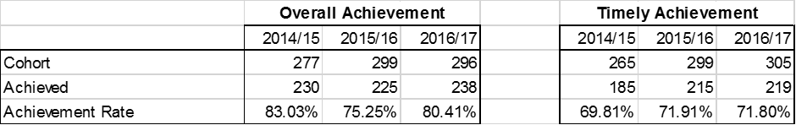

Overall success rates are good and have increased by 5% from the previous year. Success rates for all apprentices on the large majority of programmes are well above the national averages and have been for the last 3 years.

Timely Success rates have remianed broadly comparable on the previous year. This is due to good performance in Business Administration/Customer Service/Management, Engineering, Childcare and Teaching Assistant and Dental subcontracted provision. Managers’ actions in Health and Social Care, such as more-robust performance management of LDOs and more frequent visits to monitor the progress of, and provide extra support to, this group of apprentices, started to improve their progress but they did not benefit fully from the changes in order to improve timely achievement in this area. (Please see below)

Overall Success rates for the Engineering Manufacturing and Business Administration/Customer Service/Business Management and Childcare/Teaching Assistant departments remain well above national averages, with the majority of learners completing their programmes.

Please see below for individual departmental breakdowns.

Individual Departmental Breakdowns

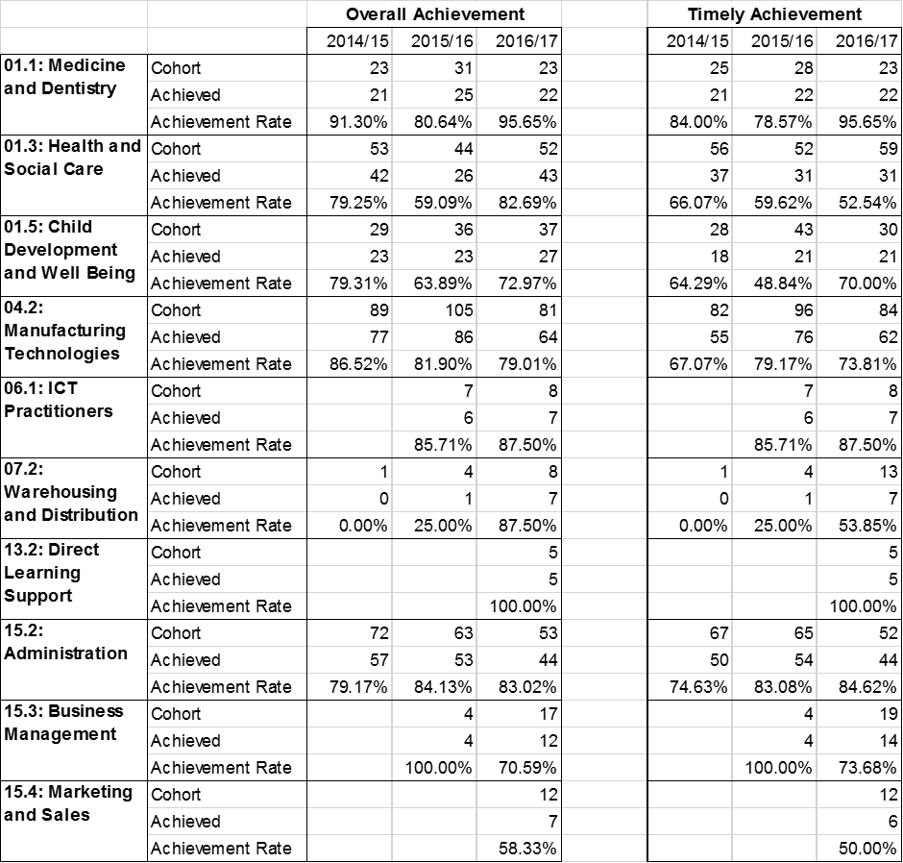

Medicine and Dentistry (Delivered by Dentrain Professional Ltd)
Overall/Timely Achievement rates are very good at 95% showing very good management of the programme and learner progress. One learner left the programme without achieving due to a contract termination and all other learners achieved on time.

Health and Social Care
Overall Achievement rates improved from 59% to 83%, showing the impact of improved performance management of staff and monitoring of learners progress. Timely achievement remained well below Alliance Learning business plan target and requires ongoing improvement to ensure the reminder of learners on programme achieve on time into 2017/18, when delivery will cease. The low timely achievement is mainly attributed to Advanced Apprentices not passing their functional skills maths exam and becoming disengaged due to family commitments in the 25+ age range. The functional skills team provided additional frequency of one to one support to help get out of funded learners to achieve these. This support was reflected in the high overall success rates, showing we are supporting learners to achieve their framework. This department remains Grade 3 (requires improvement).

Childcare
Overall Achievement rates increased from 63% to 73% meaning a 10% increase on the previous year and timely Achievement increased by 21%. This demonstrates the effective impact of the senior member of staff put in to place and highly effective performance management of the department.

Manufacturing Technologies
Overall Achievement remained good with a slight drop to 79% from the previous year. Timely achievement reduced to 73% and can be attributed to 24 learners who did not achieve in year. This was attributed to 15 early leavers; 11 were taken off in previous contract years and 4 early leavers in year 2016/17. 9 learner did not achieve in the month they were due in, due to a variety of reasons. Learners’ behaviours at work (employability) need to improve to reduce the amount of learners leaving the programme early.

ICT Practitioners (Delivered by Nowskills)
Overall and Timely Achievement were good at 87.5%. One learner left the programme without achieving due to losing their employment and all other learners achieved on time. Alliance Learning no longer subcontracts this delivery.

Warehousing and Distribution (Delivered by TTA)
Overall achievement rates were good for this area, however, timely achievement required improvement. 5 learners did not achieve their apprenticeship on time, 4 due to disengagement of functional skills for the driving good vehicles apprenticeship from both learners and employers and one learner moved roles in his employment. For this reason, Alliance Learning has removed this provision and no longer subcontracts this area.

Direct Learning Support (Supporting Teaching and Learning in schools)
This was a new delivery area for 2016/17 and of the 5 learners due to achieve in 2016/17, all achieved ensuring overall and timely achievement was hit at 100%.

Administration and Business Management
Overall Achievement rates remained good for Business Administration at 83% overall and 84% timely. 2 learners did not achieve on time and this is also attributed to 7 early leavers taken off the programme, due to redundancy or moving into a role outside of business.
Business Management overall achievement rates decreased by 30%, however, these are based on low numbers. This drop is attributed to 5 people moving out of Team Leader roles into other parts of the business at a large employer. Better IAG at the start of the programme with both the employer and apprentice has seen in year achievement rates starting to improve.

Marketing and Sales – Digital (Delivered by Nowskills)
Overall Achievement required improvement at 58%, with timely achievement at 50%. 5 out of 12 learners were early leavers in the digital marketing sector and left their apprenticeship to join other organisations who did not want them to continue their apprenticeship. 1 apprentice did not come in on the month they were expected due to personal issues. The maximum end of year achievement for this cohort at 58% fell well below our minimum levels of performance. *
*All new starts with Nowskills were stopped in November 2016 due to early leavers from Digital marketing programme. After a thorough investigation it was identified that some systems had been put in place to address the issues, however, Alliance Learning made the decision to remove this provision. Ofsted highlighted in their May 2017 report that Senior Managers took decisive action to remove the provision.

Programme Type

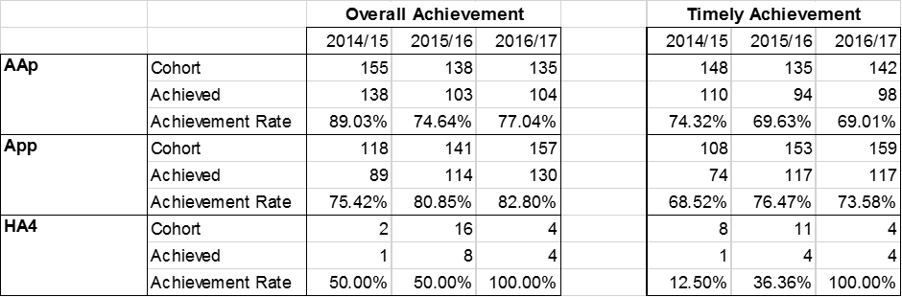

There has been a positive increase in the overall achievement rates for Advanced Apprentices. This is attributed to the late achievers mentioned above in Health and Social Care. Timely achievement has remained broadly the same.

There was a slight increase in Intermediate Apprenticeships for overall achievement rates and a slight decrease in timely achievement, which can be attrbuted to the early leavers on Level 2 Team Leader and Driving Goods Vehicle.

Higher Apprenticeship overall and timely achievement rates have significantly improved to 100% overall and timely achievement. This can be attributed to the Level 4 Higher Apprenticeship Programme that was introduced in 2015/2016, showing very good support for the small cohort of 4 apprentices and highly effective management of the departments.

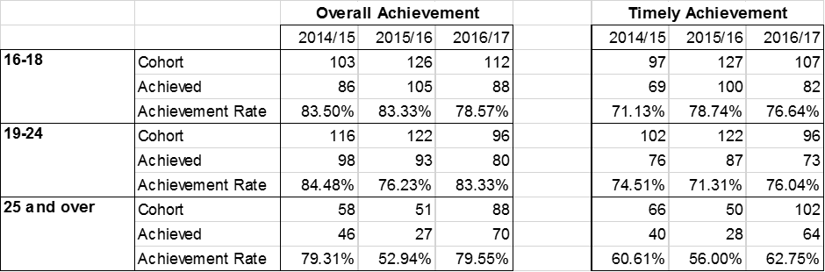

Overall achievement remained broadly comparable for all ages, however, there was a significant increase from the previous year in 25+ ages. This was due to the increase in Health and Social Care overall achievement. Timely achievement dropped from the previous year for 16-18 year olds due to the early leavers from engineering. Improved employability for work skills and what is expected whilst in employment is a highlighted area for improvement for engineering apprentices.

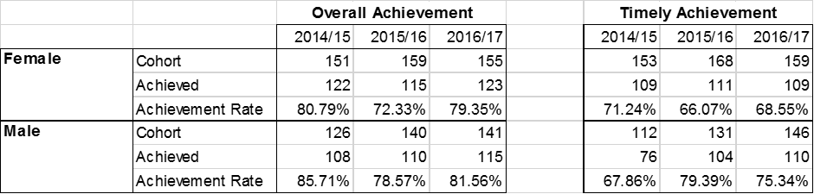

Male and female overall achievement rates remained broadly comparable although, increased from the previous year. Male learners continue to achieve slightly better overall, although, females perform less well in a timely manner. This is due to the amount of leavers in Health. There are no significant variatons in performance across all other routes.

Departmental Overviews
APPRENTICESHIPS are Good.

Engineering

Alliance Learning has 235 apprentices in this area. Overall and timely achievement rates for this area are good. Teaching, Learning and Assessment is very good, however, further development of inspirational tuition needs to be addressed. Personal development, behaviour and welfare is good with learners making good progress from their starting points, developing confidence and self-esteem. Attendance is very good for off the job training. The team are now delivering the New Standards to a small cohort of 5 learners in order to ensure a robust approach to successful delivery.

Strengths

• Very good overall and timely success rates.
• Very good Teaching, Learning and Assessment.
• Very good attendance for off the job training.
• Very good learner progress reviews.
• Employer engagement is very good.

Areas for Improvement

• Inspirational tuition needs further development
• Written feedback to learners requires further development.
• Learners’ behaviours at work (employability) to reduce early leavers.
• Recruitment of females onto engineering programmes.
• Stretch and challenge of learners’ technical knowledge.

Childcare

Alliance Learning has 47 apprentices in this area. Overall and timely achievement rates have improved as a result of appointing a senior with a 9% increase in overall and 21% increase in timely achievement. Teaching, Learning and Assessment continues to be consistently very good. Outstanding feedback has been identified along with very good practice highlighted from Standards Verifier visits. Very good learner progress reviews and 360 degree feedback shows good employer engagement.

Strengths

- Very good Teaching, Learning and Assessment.
- Feedback to learners is outstanding.
- Very good learner progress reviews.
- Very good practice highlighted from Standards Verifier visits.
- Employer engagement is good.
- Good achievement and timely achievement rates.

Areas for Improvement

- Continue to improve the overall and timely achievement to meet business plan targets
- Continued improvement to 24+ Achievement
- Progression onto higher level qualifications
- Parental engagement for 16-18 year olds

Health & Social Care

Alliance Learning has 57 apprentices in this area. In 2016/2017 the high overall achievement rates (23% increase on the previous year) demonstrated improving performance management and support for the learner to stay on programme until they ultimately achieve. Timely achievement continues to require improvement. Employer engagement is improving and strategies are in place with managers liaising with companies to improve rota planning for appointments. The appointment of an experienced Senior is helping to improve this area through a learner/employer concern register. Teaching, Learning and Assessment is good with assessors making good use of IPad technology during coaching sessions. Personal development, behaviour and welfare is adequate with the majority of learners achieving their qualification. Feedback to learners is good following assessment and through very good learner progress reviews.

Leaders and managers have recognised that the provision that the apprentices in health and social care receive is not good enough. Despite the recent changes, the pace of improvements in health and social care apprenticeship programmes had been too slow. Improvements to overall achievement rates, demonstrates some impact, however, Alliance Learning has made the decision to no longer offers Health and Social Care Apprenticeships and has removed this provision from NAS.

Strengths

- Good overall achievement rate.
- Good support to ensure learners achieve
- Effective Senior driving improvements.
- Very good learner progress reviews.
- Good Teaching, Learning and Assessment.
- Feedback to the learners is good.

Area for Improvement

- Employer engagement requires improvement.
- Timely achievement rates
- Reduction in learners leaving the programme
- Promotion of in-work attendance and improvement to 24+ Achievement
- Parental engagement for 16-18 year olds

Business Administration

Alliance Learning has 147 apprentices in this area. Overall and Timely achievement remained very good for Business Administration. Timely achievement increased by 9%, resulting in the department being 24% above the national average. An experienced Senior member of staff is firmly embedded into this department and the impact is demonstrated in the continued rise performance.
Teaching, Learning and Assessment is good with elements of outstanding features identified in observations. Feedback is motivational with clear advice on how to improve, although learner responses required more reflection. Recent SV reports in 2016-2017 state feedback is outstanding in this area, with 3 areas of good practice identified. Personal development, behaviour and welfare is good, with learners making clear progress from their starting points, developing confidence and self-esteem. This is reflected in the consistently very good achievement rates. The team are now delivering 4 New Standards to a small cohort of learners in order to ensure a robust approach to successful delivery.

Strengths

- Very good overall and timely achievement rates.
- Feedback to learners is outstanding.
- Very good Teaching, Learning and Assessment.
- Very good learner progress reviews.
- Very good use of ILT throughout the programme.
- Good employer engagement.

Areas for Improvement

- Continue to increase progression onto higher level qualifications.
- Employer engagement to increase day release numbers.
- Reflective feedback from learners.
- Parental engagement for 16-18 year olds

Dental Nursing (Dentrain)

Alliance Learning sub-contracts 47 apprentices in this area. Overall and timely achievement rates for this area remain very good and are broadly comparable with the previous year. Teaching, Learning and Assessment is good with elements of outstanding features identified in observations, alongside positive EV Reports. Feedback from learner questionnaires is positive and learners like that they can access their assessor any time during the day. Personal development, behaviour and welfare is satisfactory with learners making good progress from their starting points, developing confidence and self-esteem, although further enhancement of British Values and Prevent requires improvement.

Strengths
- Very good overall and timely achievement rates.
- Good teaching, learning and assessment
- Good learner feedback
- Good IAG

Areas for Improvement
- Enhanced promotion of PDBW
- Implementation of British Values to Learners
- Employer engagement in relation to British Values

Driving Goods Vehicles/Warehousing (Transport Training Academy)

Alliance Learning sub-contracted 13 apprentices in this area in 2016/17. Overall achievement rates are high, however, *timely achievement required improvement and was impacted by the timeliness of functional skills completion in this area. Learners were disengaged with functional skills and there is a lack of support from employers in this vocational area. Teaching, Learning and Assessment is good with as identified in observations, alongside positive EV Reports. Personal development, behaviour and welfare is satisfactory with learners making good progress from their starting points, developing confidence and self-esteem, although further enhancement of British Values and Prevent requires improvement. *Due to the low timely achievement rates, Alliance Learning removed this provision from further new delivery in April 2017.

Strengths
- Good teaching, learning and assessment
- Good IAG
Areas for Improvement
- Overall and timely achievement rates
- Enhanced promotion of PDBW
- Implementation of British Values to Learners
- Employer engagement in relation to British Values

IT Apprenticeships (Nowskills)

Alliance Learning sub-contracted 16 apprentices in this area. Safeguarding was effective. Both Overall and timely achievement rates were very good for ICT Practitioners, however, digital marketing required improvement. (*See below). Teaching, Learning and Assessment was good with SV reports confirming high standards of assessment practice. Learners made good progress and this was also reflected within the functional skills support and high overall and timely achievement.

Strengths
- Very good overall and timely achievement rates for ICT Practitioners route.
- Good teaching, learning and assessment

Areas for Improvement
- Overall and Timely achievement rates for Digital Marketing route
- Progression onto higher level qualifications
- Implementation of British Values to Learners
- More robust learner progress reviews

*All new starts with Nowskills were stopped in November 2016 due to early leavers from Digital marketing programme. After a thorough investigation it was identified that some systems had been put in place to address the issues, however, Alliance Learning made the decision to remove this provision. Ofsted highlighted in their May 2017 report that Senior Managers took decisive action to remove the provision.

Traineeships

In 2015/16 and early 2016/17, managers offered traineeships for a small number of trainees, but too few trainees achieved. A significant number of trainees who did not complete started other courses or gained jobs. Having reviewed the quality of traineeships and the low achievement rates of the trainees, managers at Alliance Learning stopped delivering these courses from January 2017.

